UNITED STATES

SECURITIES AND EXCHANGE COMMISSION

Washington, D.C. 20549

FORM 6-K

REPORT OF FOREIGN PRIVATE ISSUER PURSUANT TO RULE 13a-16 OR 15d-16 UNDER THE SECURITIES EXCHANGE ACT OF 1934

For the month of October 2023

Commission File Number: 001-39989

PYROGENESIS CANADA INC.

(Translation of registrant's name into English)

1744, William St. Suite 200

Montreal, QC, H3J1R4
Canada

(Address of principal executive office)

Indicate by check mark whether the registrant files or will file annual reports under cover of Form 20-F or Form 40-F. Form 20-F [ ] Form 40-F [ X ]

On October 3, 2023, the Registrant issued a press release, a copy of which is attached hereto as Exhibit 99.1 and is incorporated herein by reference.

EXHIBIT INDEX

Exhibit Number |  |  | Description
99.1 |  |  | Press Release dated October 3, 2023

SIGNATURES

Pursuant to the requirements of the Securities Exchange Act of 1934, the registrant has duly caused this report to be signed on its behalf by the undersigned, thereunto duly authorized.

 | PYROGENESIS CANADA INC.
 |  | (Registrant)
Date: October 3, 2023 |  | /s/ P. Peter Pascali
 |  | P. Peter Pascali
 | Chief Executive Officer

EXHIBIT 99.1

PyroGenesis Provides Update on the PUREVAP™ Quartz Reduction Reactor and Fumed Silica Projects with HPQ Silicon Inc.

Prepares for Milestone Silicon Pour on Route to Full Commercialization

MONTREAL, Oct. 03, 2023 (GLOBE NEWSWIRE) -- PyroGenesis Canada Inc. (http://pyrogenesis.com) (TSX: PYR) (NASDAQ: PYR) (FRA: 8PY), a high-tech company (the “Company” or “PyroGenesis”) that designs, develops, manufactures and commercializes advanced plasma processes and sustainable solutions which are geared to reduce greenhouse gases (GHG) and address environmental pollutants, is pleased to provide, further to HPQ Silicon Inc’s (“HPQ” or the “Client”) press release

dated September 28th, 2023 and the Company’s news release dated June 1, 2023, an update on its strategic engineering partnership with HPQ on two projects: (i) the PUREVAP™ Quartz Reduction Reaction (QRR) pilot plant and (ii) the Fumed Silica Reactor (“FSR”) project. As part of the terms of both projects with HPQ, PyroGenesis benefits from a royalty payment representing 10% of the Client’s eventual sales, with set minimums. With respect to the FSR with HPQ Silica Polvere Inc. (“HPQ Polvere”), a wholly owned subsidiary of HPQ, this royalty stream, can, at any time, be converted by PyroGenesis into a 50% ownership in HPQ Polvere.

Given the number of inquiries received by investors, PyroGenesis provides the following update:

PUREVAP™ Quartz Reduction Reactor (QRR) Project

The innovative QRR pilot plant was designed and built to transform lower-purity quartz (SiO₂) into high-purity silicon (Si) in a single step. The QRR, which uses electric high temperature plasma arc, reduces production costs and significantly lowers energy consumption with a smaller carbon footprint compared to traditional methods.

As noted by HPQ, the demand for silicon (Si) is projected to surpass 3.8 million tonnes and be valued between US$15 billion and US$20 billion by 2025. This projection doesn’t consider the additional 300,000 tonnes of demand for silicon-based anode material projected by 2030 arising from demand in the battery market, representing an additional market valued at approximately US$ 15 billion. The global silicon anode battery market is valued at US$65.5 billion in 2022 and is expected to reach US$123.1

billion by 2030, for a CAGR of 22.3% during the forecast period of 2023-2030.¹

As highlighted in HPQ's recent press release, significant milestones have been reached in the pilot plant project, leading to a silicon pouring step – an important milestone for both PyroGenesis and HPQ that marks the completion of the pilot stage and sets the stage for commercial production.

The past few weeks have seen noteworthy progress and confirmations:

Completion of the scaling up of the QRR process by 2,500x from the previous laboratory scale, validating the original proof of concept.
Demonstration of operation in a semi-continuous batch cycle.
Production of silicon from quartz using a one-step direct carbothermal reduction process.
25% reduction in raw material use compared with conventional methods.
Achievement of 3N+ (or 99.9+%) silicon purity, a crucial purity level for battery-grade silicon applications.
Optimized QRR design for high performance during the tapping process, minimizing silicon contamination.
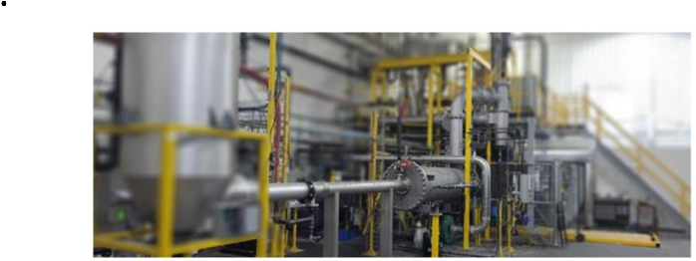

Figure 1 - Picture of Gen3 PUREVAP™ Quartz Reduction Reactor (QRR) pilot plant

Next Steps for PUREVAP™: The Path to Commercialization

Further testing of the enhanced system will conclude with a silicon pouring step, which is scheduled within the next few weeks.

After a successful pour, PyroGenesis and HPQ will determine the number of PUREVAP QRR systems required to construct a full commercial plant and thereafter will move towards full commercialization.

Preliminary assessments have revealed that a minimum of two initial reactors, each capable of producing 2,500 MT of high-purity silicon per year, would be required - at a build cost to HPQ of at least $20 million each. PyroGenesis will be the engineering partner contracted to build these units. This assessment will be validated and finalized.

“The next milestone is to conclude a successful pour; however, we caution that we have had delays and interruptions in the past and as such, nothing is certain until completed,” said Mr. P. Peter Pascali, CEO and President of PyroGenesis. “We are highly confident that the pour will take place and we don’t have any reason to believe that it will not be successful. We believe the QRR is a major step forward for PyroGenesis and HPQ as providers of a technology that could help shape the future of silicon production. The market's enormous growth potential signals not only profitability but the protection of a key critical mineral and a brighter, more sustainable future. As we close in on a successful silicon pour, we are excited by what lies ahead in the development of the full commercial plant.”
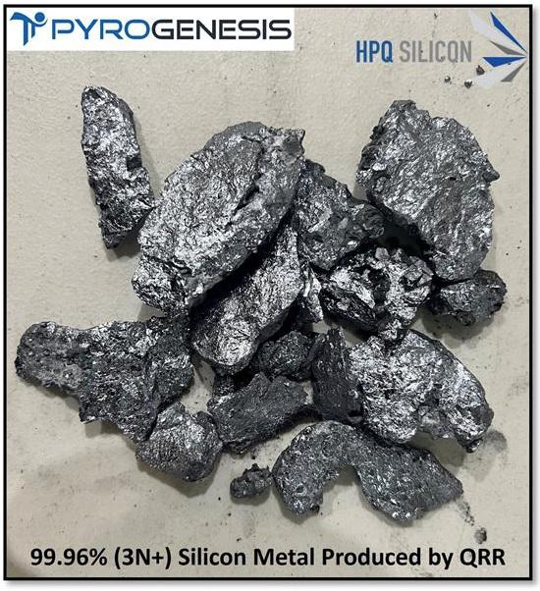

Figure 2 – Picture of 3N+ Purity Silicon Metal Produced by QRR Fumed Silica Reactor (FSR) Project

The Fumed Silica Reactor (FSR), another plasma-based process, converts quartz into fumed silica (Pyrogenic Silica) in a single and eco-friendly step. By eliminating the use of harmful chemicals generated by conventional methods the groundbreaking FSR approach, if successful, will help contribute to the repatriation of silica production to North America.

Conventional fumed silica processes, which rely on silicon metal (Si) as raw material, not only have a significant carbon footprint of around 9.5 tonnes of CO₂ equivalent per tonne of fumed silica, but also present complex process challenges which include, but
are not limited to, using hazardous materials.²

In contrast, the FSR offers an innovative solution by converting quartz directly into fumed silica, providing a sustainable alternative. This pioneering technology not only provides a solution to increasing market demand, but also significantly reduces CO₂ emissions by over 60%, (equivalent to around 5 tonnes of CO₂ equivalent per tonne of fumed silica produced) while not

utilizing hazardous materials in the process. Once again, this project along with the quartz to silicon represents an essential step towards a more sustainable and environmentally friendly future.

In a major step towards commercial-scale production, PyroGenesis has successfully deployed the FSR on a laboratory scale, resulting in the milestone production of fumed silica. Preliminary tests and analysis have confirmed that the material produced has chemical and physical characteristics compatible with those of commercially available fumed silica.

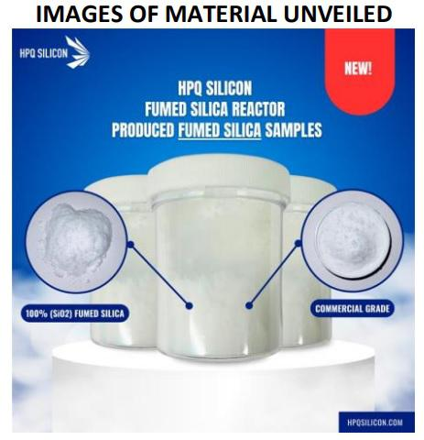

Figure 3 - Picture of Fumed Silica Commercial Grade produced by PyroGenesis for HPQ Next Steps for Fumed Silica Reactor: The Path to Commercialization
“In the FSR project, PyroGenesis is the unique supplier of a technology capable of using quartz (SiO₂) as a raw material to produce commercial-grade fumed silica, in a single step. With the lab-scale production of commercial-grade fumed silica now complete, we now can move towards the long anticipated next phase: a pilot plant scheduled to start operations in the second quarter of 2024,” continued Mr. Pascali. “In light of global demand, it is worth noting that the fumed silica market, valued at US$1.3 billion in 2022, is expected to grow at a CAGR of 5% to reach US$2.1 billion by 2032. Fumed silica sales accounted for

almost 23% of the global specialty silica market at the end of 2021.³”

PyroGenesis’ involvement in developing high-purity silicon and fumed silica from quartz is part of PyroGenesis’ three-tiered solution ecosystem that aligns with economic drivers that are key to global heavy industry. High-purity silicon is part of PyroGenesis’ Commodity Security & Optimization tier, where the recovery of viable metals and the optimization of production to increase output helps to maximize raw materials and improve the availability of critical minerals. Silicon has been identified as a critical mineral by many governments worldwide.

About PyroGenesis Canada Inc.

PyroGenesis Canada Inc., a high-tech company, is a proud leader in the design, development, manufacture and commercialization of advanced plasma processes and sustainable solutions which reduce greenhouse gases (GHG) and are economically attractive alternatives to conventional “dirty” processes. PyroGenesis has created proprietary, patented and advanced plasma technologies that are being vetted and adopted by multiple multibillion dollar industry leaders in four massive markets: iron ore pelletization, aluminum, waste management, and additive manufacturing. With a team of experienced engineers, scientists and technicians
working out of its Montreal office, and its 3,800 m² and 2,940 m² manufacturing facilities, PyroGenesis maintains its competitive advantage by remaining at the forefront of technology development and commercialization. The operations are ISO 9001:2015 and AS9100D certified, having been ISO certified since 1997. For more information, please visit: www.pyrogenesis.com.

Cautionary and Forward-Looking Statements

This press release contains “forward-looking information” and “forward-looking statements” (collectively, “forward-looking statements”) within the meaning of applicable securities laws. In some cases, but not necessarily in all cases, forward-looking statements can be identified by the use of forward-looking terminology such as “plans”, “targets”, “expects” or “does not expect”, “is expected”, “an opportunity exists”, “is positioned”, “estimates”, “intends”, “assumes”, “anticipates” or “does not anticipate” or “believes”, or variations of such words and phrases or state that certain actions, events or results “may”, “could”, “would”, “might”, “will” or “will be taken”, “occur” or “be achieved”. In addition, any statements that refer to expectations, projections or other characterizations of future events or circumstances contain forward-looking statements. Forward-looking statements are not historical facts, nor guarantees or assurances of future performance but instead represent management’s current beliefs, expectations, estimates and projections regarding future events and operating performance.

Forward-looking statements are necessarily based on a number of opinions, assumptions and estimates that, while considered reasonable by the Company as of the date of this release, are subject to inherent uncertainties, risks and changes in circumstances that may differ materially from those contemplated by the forward-looking statements. Important factors that could cause actual results to differ, possibly materially, from those indicated by the forward-looking statements include, but are not limited to, the risk factors identified under “Risk Factors” in the Company’s latest annual information form, and in other periodic filings that the Company has made and may make in the future with the securities commissions or similar regulatory authorities, all of which are available under the Company’s profile on SEDAR at www.sedar.com, or at www.sec.gov. These factors are not intended to represent a complete list of the factors that could affect the Company. However, such risk factors should be considered carefully. There can be no assurance that such estimates and assumptions will prove to be correct. You should not place undue reliance on forward-looking statements, which speak only as of the date of this release. The Company undertakes no obligation to publicly update or revise any forward-looking statement, except as required by applicable securities laws.

Neither the Toronto Stock Exchange, its Regulation Services Provider (as that term is defined in the policies of the Toronto Stock Exchange) nor the NASDAQ Stock Market, LLC accepts responsibility for the adequacy or accuracy of this press release.

For further information please contact:
Rodayna Kafal, Vice President, IR/Comms. and Strategic BD
Phone: (514) 937-0002, E-mail: ir@pyrogenesis.com

RELATED LINK: http://www.pyrogenesis.com/

- https://www.databridgemarketresearch.com/reports/global-silicon-anode-battery-market/amp

- 2012 – Executive summary: “SILICON-CHEMISTRY CARBON BALANCE, AN ASSESSMENT OF GREENHOUSE GAS EMISSIONS AND REDUCTIONS”, Covering the Production, Use and End-of-Life of Silicones, Siloxanes and Silane Products in Europe, North America, and Japan. [Pages 20 to 21] (Commissioned by Global Silicones Council, Centre Européen des Silicones, Silicones Environmental, Health and Safety Council of North America Silicone Industry Association of Japan).

- https://www.factmr.com/report/2301/fumed-silica-market Photos accompanying this announcement are available at https://www.globenewswire.com/NewsRoom/AttachmentNg/9a111bf8-bffe-4b96-8f3f-547efe73015d https://www.globenewswire.com/NewsRoom/AttachmentNg/39db1cd7-ace7-4434-bd9b-806cae8e0cdb https://www.globenewswire.com/NewsRoom/AttachmentNg/119d2c77-7820-4ae1-9a7a-c9cb6263164c

